Recursion is a programming technique in which a method calls itself to solve a problem by breaking it into smaller subproblems. Every recursive function has:
- Base Case: Stops the recursion.
- Recursive Case: Calls the function again with a smaller input.

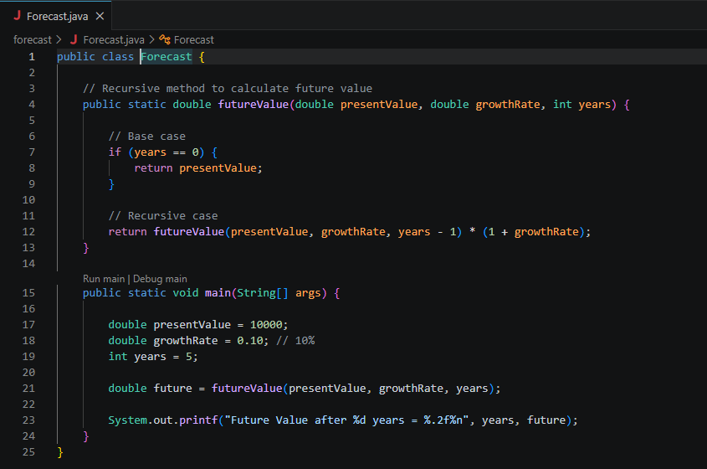

OUTPUT:

